**Software Requirements**

**Specification**

**For**

**<Accommodation Management System>**

**22.11.2020**

|  |  |
| --- | --- |
| **Name of Group Members** | **#ID** |
| Fariha Rahman | 1512333042 |
| Umma Kulsum Shusmita | 1520572642 |
| Abrar Yasir | 1530069042 |
| Md.Hasibur Rahman Khan |  |

**Table of Contents**

|  |  |  |
| --- | --- | --- |
| **Serial No** | **Contents** | **Page No** |
| 1 | Introduction | 1 |
| 1.1 | Purpose | 1 |
| 1.2 | Product Scope | 1 |
| 2 | Overall Description | 1 |
| 2.1 | Product Features | 1 |
| 2.2 | User classes/roles & Characteristics | 1 |
| 2.3 | Operating Environment | 2 |
| 3 | Functional Requirements | 2 |
| 3.1 | System Feature Execute | 2 |
| 3.2 | Use Case Diagram for Functional Requirements | 3 |
| 3.3 | Priority | 4 |
| 4 | Non-functional Requirements | 4 |
| 4.1 | Performance | 4 |
| 4.2 | Quality Attributes | 4 |
| 4.3 | Environment Restrictions | 4 |

**1.  Introduction**

**1.1 Purpose**

The purpose of this document is to specify the requirements and preview some elements of an Accommodation System Management.

**1.2 Product Scope**

Our project is an Accommodation System, which is basically designed for armed forces or big companies. This is basically a smart accommodation management system, where our moto is to develop existing system leads to the designing of Computerized systems that will be much better than to existing manual system.

**2. Overall Description**

This section gives about the background information about the specific requirements of reminder application program. This section will describe the product that will affect the final product.

**2.1 Product Features**

**Home Page**

**Registration Page**

**User Dashboard**

**Officer of Command Dashboard**

**Approval Page**

**AOC Dashboard**

**AOC Quarter**

There will be one or two more to include.

**2.2 User classes**

1. System Admin – The system admin will have the control of the whole management system.
2. System User – Every user need to create an account, and the account will be find out by different ID’s, will have the access of own profile and applications.
3. AOC – The admin, the senior personals will have the access to this section, will be verified from different areas.
4. Allocation
5. Profile – Each user will have their own individual profile.
6. Migration

**2.3 Operating Environment**

This system can be accessed from computer or mobile.

**Software Required**

1. PHP
2. HTML
3. CSS
4. Bootstrap
5. Javascript
6. MySql Database
7. Laravel framework

.

**3. Functional Requirements**

**3.1 Use Case Diagram**

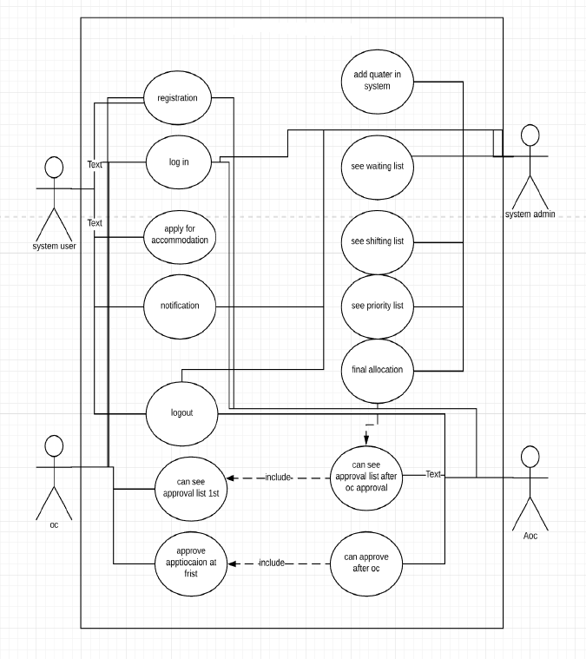

**Use Case Diagram**

**3.3 Priority**

**High Priority Features -**

1. Add User

2. Verifying user using ID or name

3. Profile

4.Area of Command Selection

5. Erase

**Medium Priority Features -**

1. Migration

**Low Priority Features -** 1. Allocation

**4 Non-functional Requirements**

**4.1 Performance**

The system shall have good performance and be responsive. It shall be fast. The

The system shall also minimize memory usage. Will be easy to fulfill the requirements properly.

**4.2 Quality Attributes**

**Portability -** The application shall be portable. It shall be able to run on any OS both in computer and mobiles. Only there’s a need of internet connection.

**Reusability and Adaptability -** The application shall be reusable and adaptable. It shall abstract all method calls to the MySql database.

**Usability and Reliability -** The application shall be user ­friendly and shall be error­ free.

**4.3 Environment Restrictions**

1. It requires internet and won’t work in offline .

2. Project interface is quite simple and less worked on .

THANK YOU